## ASSEMBLY STEP BY STEP.

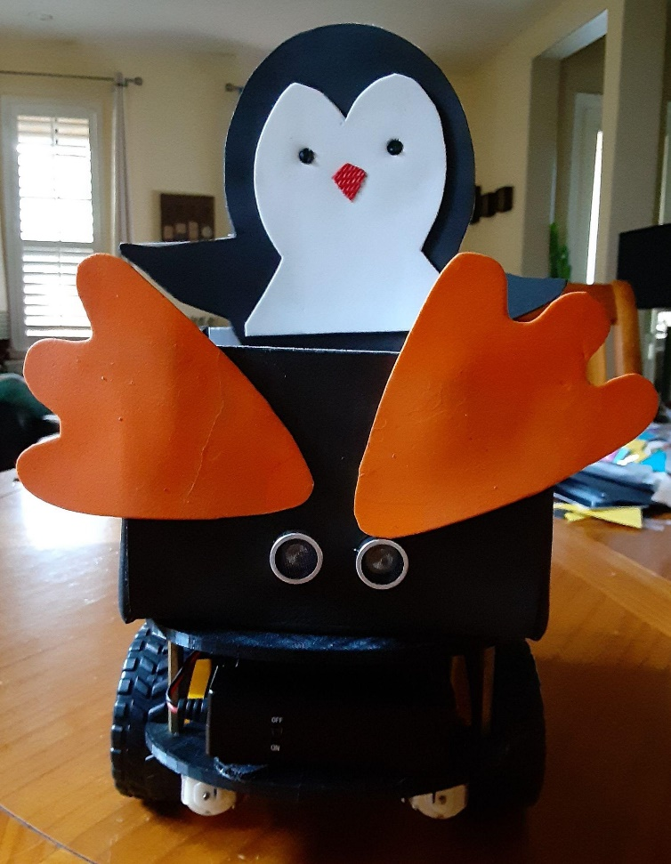

Image 2: Penguin Robot final photo.

### STEP 1: Build the lower chassis and attach the motors.

1. A picture containing metalware

   Description automatically generatedHave a 3D printed chassis that fits in a 6 x 6 x 6 inches box. Composed of 2 tongue-and-groove boards. Secure their union with 4 plastic bolts M3x10mm.

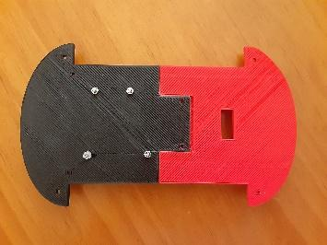

1. Have 4 servo motors. Attach the servo motors to the chassis using 2 long socket bolts to the metal block. Then turn the block facing up and attach it to the chassis using the 2 small bolts like in the last picture.

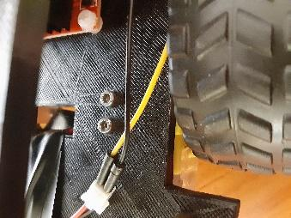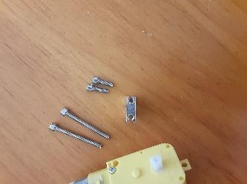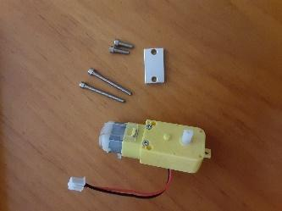

1. Take the 4 servo motors power cables out through the chassis holes for the future connection with the L298 Motor driver board.

1. Attach the wheels to the servo motors selecting the right wheal center position and applying simple hand pressure.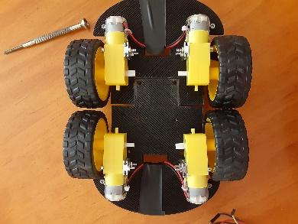

### STEP 2: Attach the “L298 Motor driver dual H-bridge” to the lower chassis and connect the motors to it.

1. Attach the “L298 Motor driver dual H-bridge” with 4 plastic bolts M3x10mm. Use the same position where the 2 chassis parts join.

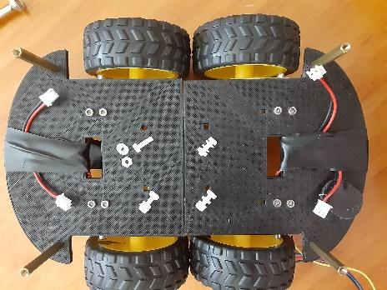

1. Connect the servo motors to the L298 Motor driver terminals. As illustrated in the first picture, both motors on the left together connect to the left terminal on the H-bridge. The right-side motors connect also together to the right terminal.

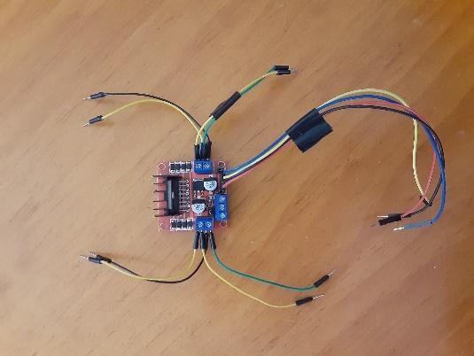

1. As shown on the picture, use a 4-rainbow female-male header cable to connect the L298 Motor driver inputs to the Arduino-1, which will control the motors movements through the Arduino program.

1. As shown in the picture connect the cables that will input power from the 9 Volts battery. 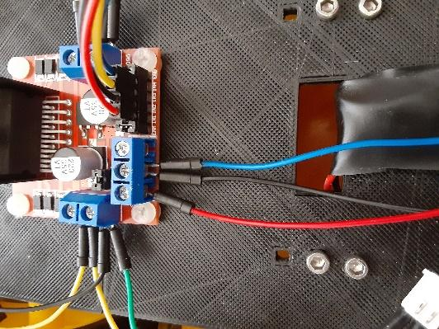
   1. On the L298 Motor driver 12 Volts input connects the battery positive output.
   2. On the L298 Motor driver Ground connects the battery negative output together with a Ground connection from the Arduino-1.

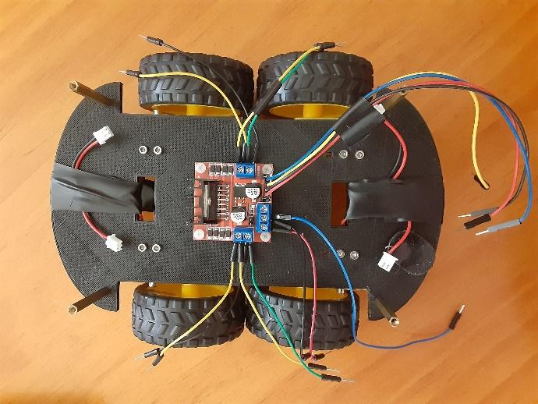

* 1. After all previous connections the result must be as in the second picture.

1. Plug the servo motors to the L298 Motor driver terminals cables to the servomotors female as in the picture

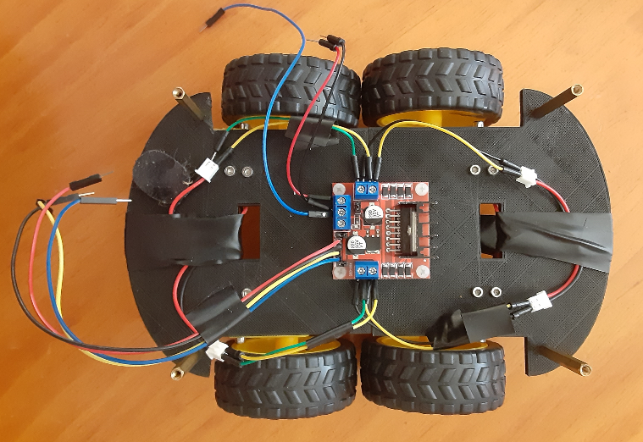

1. A picture containing electronics

   Description automatically generatedPlug the L298 Motor driver power input cables to the battery female as in the picture.

### STEP 3: Build the upper chassis and attach the Arduino-1 board.

Connect Arduino-1 outputs to the L298 Motor driver inputs to control wheel movements.

1. Attach the “Arduino-1” with 4 plastic bolts M3x10mm. Use the same position where the 2 chassis parts dovetail together.

1. A picture containing indoor, weapon

   Description automatically generated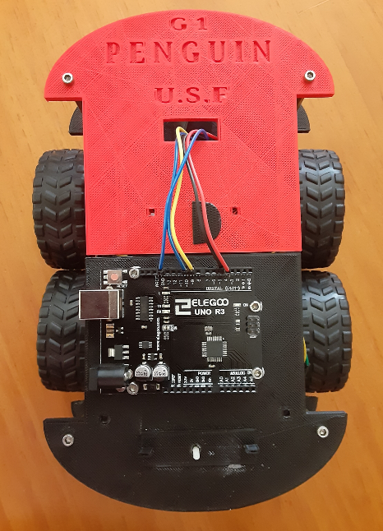As shown in the pictures, join the lower and upper chassis using the 4 thin cylinders headed by hexagon socket bolts (one for each chassis). Having the result on the last picture.

Connect the Arduimo-1 outputs to the L298 Motor driver inputs:

* 1. L298 INP1 to Arduino-1 pin 4
  2. L298 INP2 to Arduino-1 pin 5
  3. L298 INP3 to Arduino-1 pin 9
  4. L298 INP4 to Arduino-1 pin 10
  5. L298 Ground to Arduino-1 Ground

### STEP 4: Connect the HSR-04 ultrasonic sensor to the Arduino-1.

Now the Penguin robot is sensing the distance from objects and thinking where to go.

1. Attach the ultrasonic sensor to a 3D printed small plastic PLA screen with 4 M1.6x8 bolts and attach this sensor screen base to the upper chassis front with a M3x10 bolts, shown in the pictures.

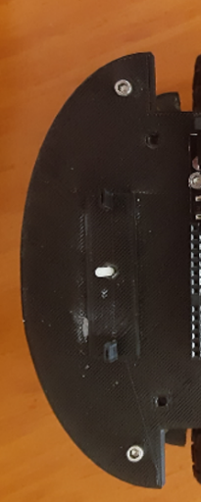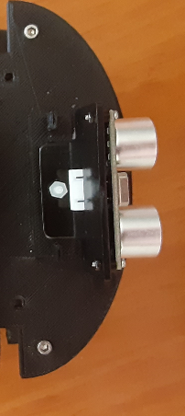Use 4 rainbow female-male headed cables to connect the ultrasonic sensor with the Arduino-1 as in the picture

* 1. Ultrasonic sensor VCC pin (voltage input) to Arduino-1 5 Volts output.
  2. Ultrasonic sensor Ground to Arduino-1 Ground
  3. Ultrasonic sensor Trigger to Arduino-1 pin 7
  4. Ultrasonic sensor Echo to Arduino-1 pin 8

1. 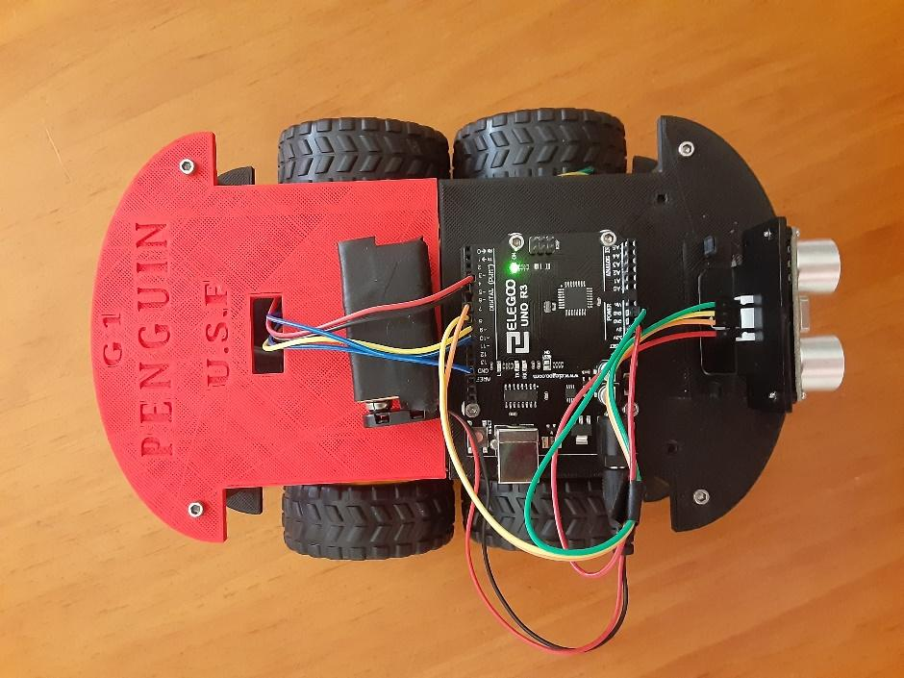Connect a 9 Volts battery to power the Arduino-1 through the Arduino-1 9V input. Attach the battery using a Velcro strap as in the picture.
2. 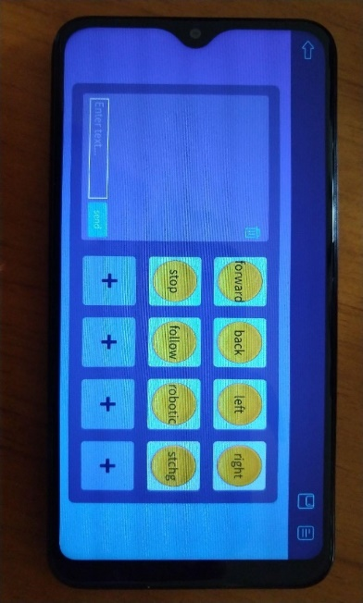Upload the Penguin robot program to the Arduino-1 board through the USB port and test it. More about the robot program is explained in the Software Lead section.
3. The Penguin robot can be remote controlled using a phone ELEGOO BLE Tool application through Bluetooth connection.
4. **A picture containing text, floor

   Description automatically generated**Build a foam Penguin box that carries small objects on the top of the Penguin base covering the electronics. Decorate it with stickers if it inspires the smaller ones.

with the following result:

